1. Regression with Neural Networks

1.1 Simple Regression with neural networks
1.1.a) Learned function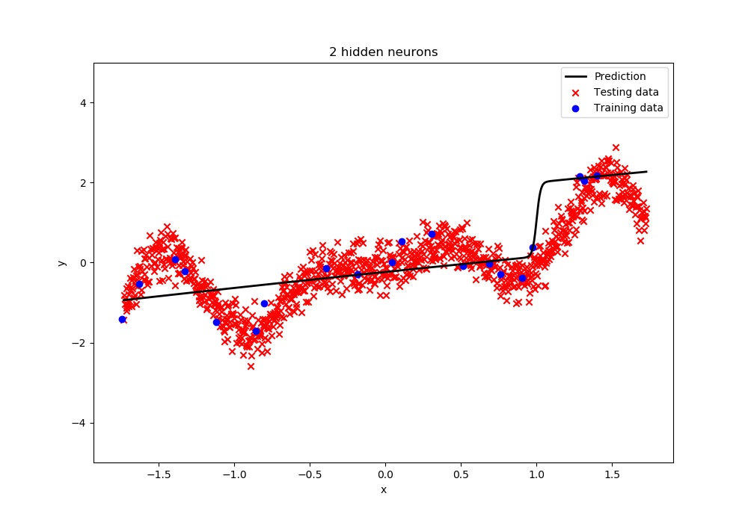
Learned Function, 2 hidden neurons
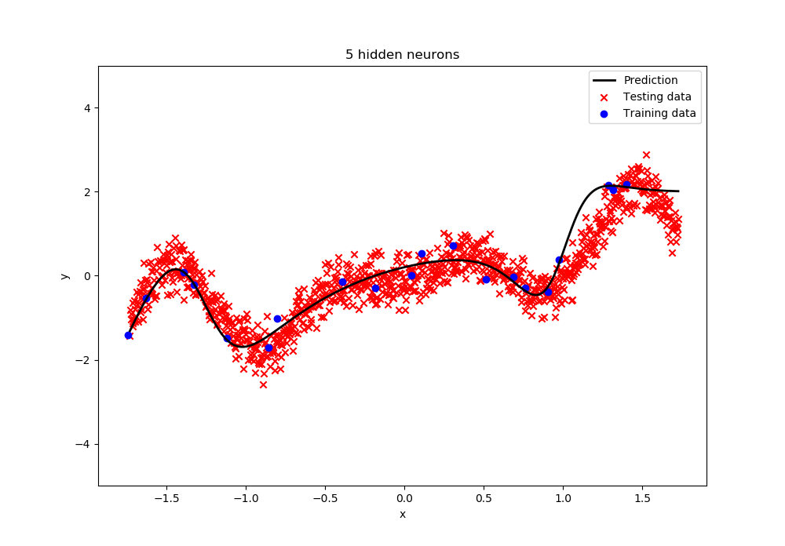
Learned Function, 5 hidden neurons
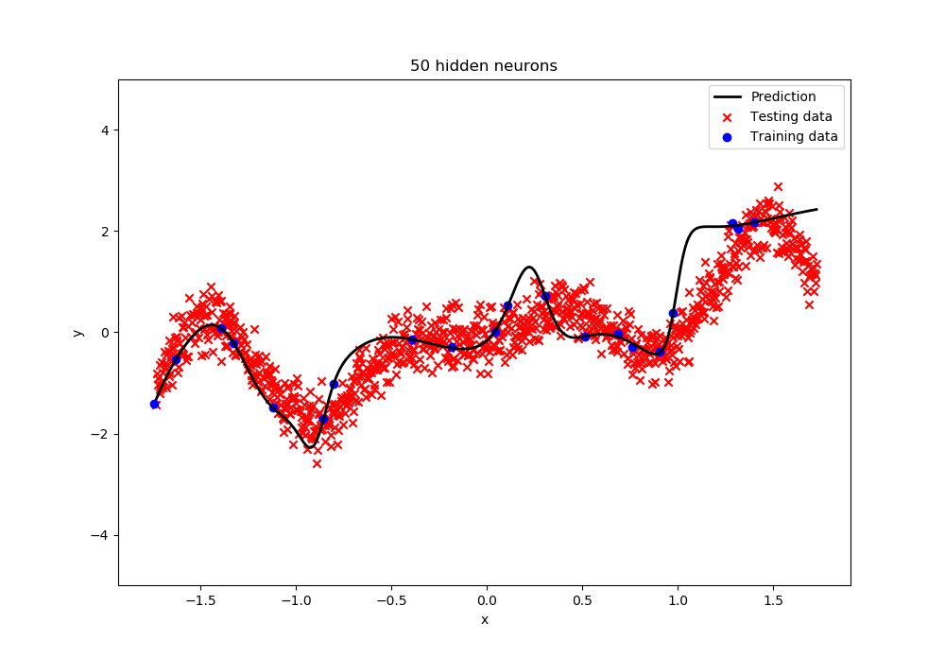
Learned Function, 50 hidden neurons
It is clearly visible that when using 2 hidden neurons that the network does not represent all the necessary generalizations and the learned function is way to linear to be a good fit for our data. Hence it is underfitted. Meanwhile when using 50 hidden neurons the functions is good for the training data but not for the testing data, hence it is overfitted. Using 5 hidden neurons is optimal for all our data.

1.1.b Variability of the performance of deep neural networks
Training Minimum | 0.03216407647258996
Training Maximum | 0.2626951418078808
Training Mean | 0.1526015800876938
Training Standard deviation | 0.06763013953143274
Seed of training minimum | 3
Seed of testing minimum | 7

A validation set to choose the best seed is needed because, with the additional validation set every seed gets tested and the seed that has the lowest error gets chosen.
The seed directly influences the weights at the initialization and the weights have an influence on the MSE, therefor the MSE is different for each seed, even though the algorithm converges.
The source of randomness that is introduced by SGD Is the randomly chosen datapoint at each step to calculate the derivate. [1]
The source of randomness that persists if SGD is replaced by standard Gradient descent is the starting configuration.

1.1c Varying the number of hidden neurons
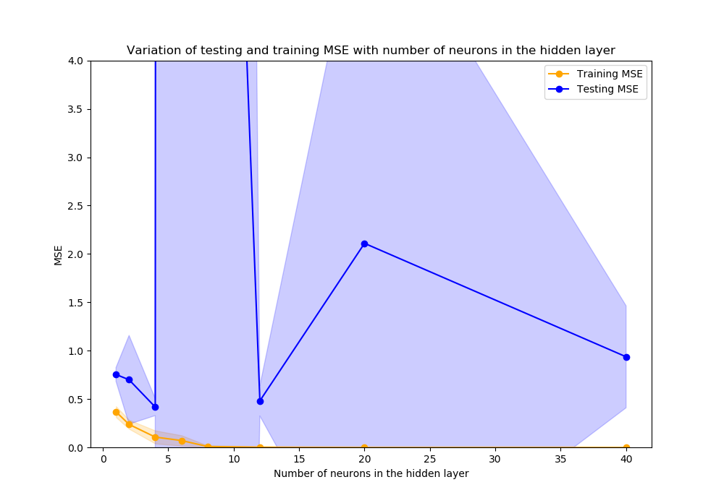
MSE to number of neurons in the hidden layer

To choose the optimal number of neurons in the hidden layer, independent of the seed, the average MSE over 10 different random seeds for, different numbers of neurons is computed. This is visualized in the figure above. There it is clearly visible, that the lowest averaged MSE over all 10 random seeds is achieved when using 4 hidden neurons. The learned function with 4 neurons in the hidden layer is presented in the figure below. In the above figure it is also possible to recognize under and overfitting. For less than 4 neurons the averaged training MSE is relatively high, so is the averaged testing MSE, therefore underfitting occurs. For more than 8 neurons the averaged training MSE is low but the averaged testing MSE is still rather high, therefore overfitting occurs.
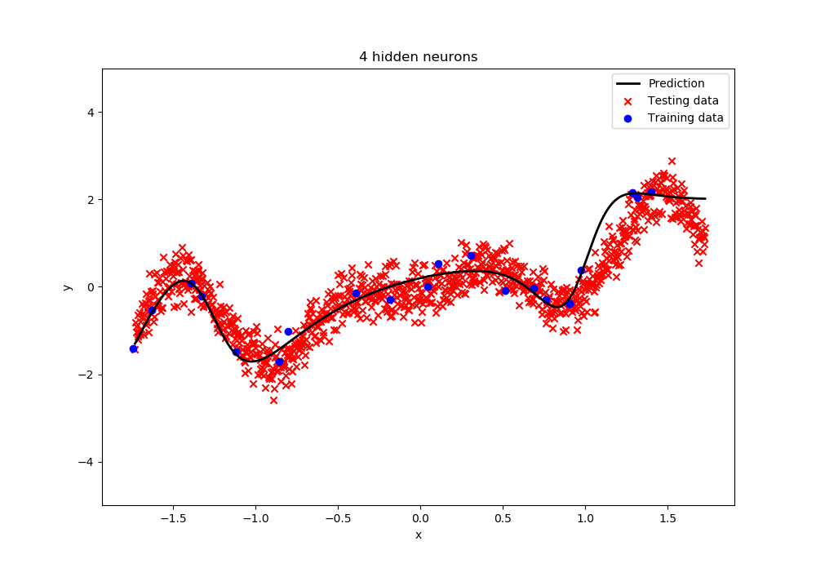
learned function, 4 hidden neurons
1.1d) Change of MSE during the course of training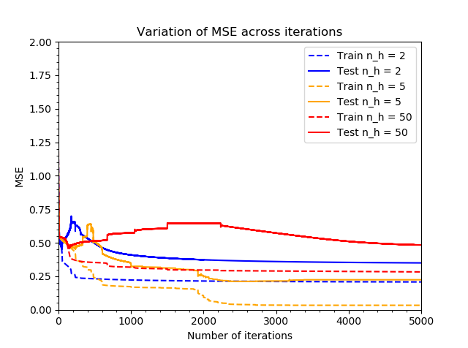
MSE across iterations
Thanks to Tasks 1.1a to 1.1c we already know that overfitting does not occur for 2 and 5 hidden neurons. So, it is sufficient to show at visualization of the MSE across iterations for 50 hidden neurons in the above figure to show that the risk of overfitting decreases or increases with iterations. There we see that the test MSE rises at the beginning and after around 2250 iterations it starts to steadily sink. Therefore, we can conclude that the risk of overfitting increases with iterations.
The feature of stochastic gradient descent that helps to overcome overfitting is that for each iteration only one data point is used to train the model. Even if the training data is overfitted in several iterations, it will still be generalized since the training data subset is so small that overfitting is not critical. [2]

